Jill Cowan Matplotlib Homework Unit 5

Pymaceuticals

For this assignment, we were asked to analyze *in vivo* data from a fictitious pharmaceutical company who was testing the efficacy of potential drug treatments for squamous cell carcinoma. A group of 250 mice were monitored after administration of a variety of drug regimens over a 45-day treatment period. The impact of three of these drug treatments (Capomulin, Infubinol and Ketapril) on tumor growth, metastasis and survival rates were monitored, along with Placebo. The results and conclusions are summarized below.

* Of the three treatment options, Capomulin was the only drug showing efficacy in reducing tumor size with a 24% reduction over the 45-day course of treatment. Infubinol and Ketapril displayed similar effects as Placebo, demonstrating no effect on tumor volume reduction, but in contrast, displayed an adverse effect with a 32% and 36% increase in tumor volume, respectively. See **Figure 1, Tumor Change Over 45 Day Treatment**.

**Figure 1**

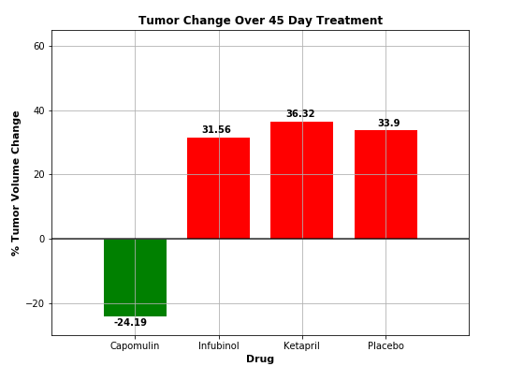

* The efficacy of Capomulin was furthered demonstrated in the mean metastatic site data shown in **Figure 2, Metastatic Sites Versus Treatment Days**. While new metastatic sites were seen across all regimens, treatment with Capomulin slowed the formation of metastatic sites to an average of 1.5 new sites versus treatment with Infubinol (2.1 new sites), Ketapril (3.3 new sites) and Placebo (3.4 new sites) over the course of the 45-day treatment period.

**Figure 2**

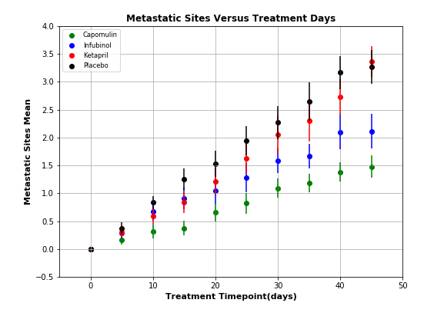

* The survival rates over the 45-day treatment period were plotted in **Figure 3, Survival During Treatment.** At the end of the drug treatment regimens, the highest overall survival rate was seen with Capomulin (84%). Ketapril, Infubinol and Placebo all displayed significantly lower survival rates at the end of the treatment period, with rates of 44, 36 and 44% respectively.
* Of the three drug treatments, Capomulin showed the most promise in treating squamous cell carcinoma.

**Figure 3**

